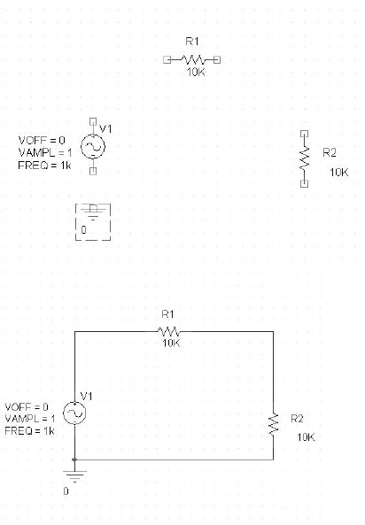
It is now time to wire the components to one another. This can be done
by placing a wire. Place Wire and Shift-w is the shortcut!
Click on a
pin then drag to mouse to another pin and click again.
When the components are all wired together, leave the wiring mode by
hitting theEsc key.
Your circuit should look like mine below.
We now are ready to simulate the circuit. We must first prepare a
simulation profile where we describe how we want the simulation to be
performed. To do this selectPSpice and then New Simulation Profile.
The following dialog box appears. I have entered a name for the
simulation. I decided to call it tran. You may call it anything you
wish. Click on theCreate button to create the profile.
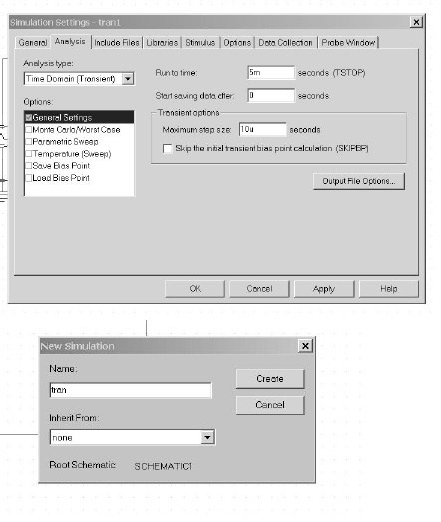
After clicking on theCreate button, the following dialog box will
appear. Since the input frequency is 1 kHz which has a corresponding
period of 1 ms, I have decided to run for 5 msi.e. 5 periods of the
waveform. I also desire 100 data points per period of the sinusoid so
I have indicated that the maximum step size be 10µs (1µs / 100 = 10
µs)
We also need to tell PSPICE which nodes we would like to plot.
We do
this by going to the main menubar and selectingPSpice. We then select
Markersand Voltage.
We place the marker on the output of the voltage
divider as shown below.
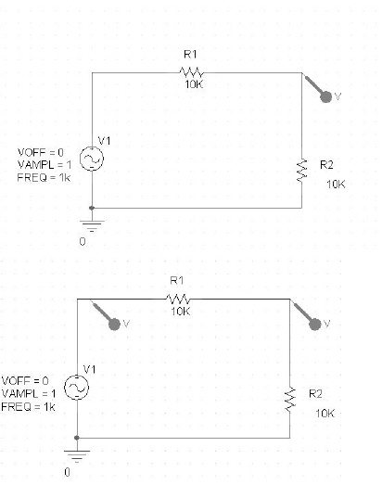
For comparison purposes, let's also place a marker on the input node as
illustrated in the figure below.
At this point we should probably save our work. This can be done by
either typing Ctrl-S or by clicking on the diskette icon in the toolbar
or by going to theFile menu and selectingSave.
We are now ready to run the PSPICE simulation. We do this by selecting
PSpice from the main menubar and then Run. We could also click on the
the arrow icon on the toolbar. After a few seconds another window will
open and you will see the following simulation traces.
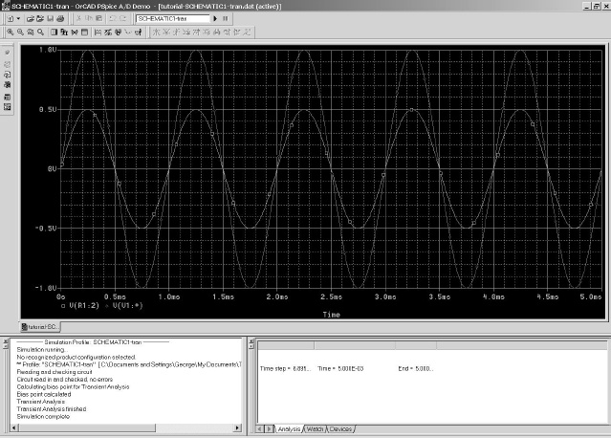
Notice the green trace (output) has one-half the amplitude of the red
trace (input) as we predicted.
Congratulations!!! You have successfully run PSpice to simulate a
simple voltage divider.

